Kiwis Shifting from Cities to Regions

This lead paragraph from the latest Infometrics NZ newsletter caught me. “We’ve never had complete and official data on how Kiwis are shifting across New Zealand, but Stats NZ has recently included some net internal migration data which provides a first cut of Kiwis’ mobility……….Population changes fall into three broad categories: natural increase (births minus deaths), net internal migration (net people from elsewhere in New Zealand shifting to the area) and international migration (net people shifting to an area from outside the country).”
Seems the stats have never broken down the data into the three chunks. Demography having never fascinated me, I was unaware of the knowledge gap. But the 2020 trends are compelling and make intuitive sense, based on observation and anecdotes.
The cities “releasing” escapees to the regions are led by Auckland (-12,600), Christchurch (-1,900) and Wellington (-1,400). In all, 7 of 13 cities gave up citizens to the regions. The regions welcoming these folks rank as Selwyn (+2,100), Tauranga City (+1.900), Waikato District (+1,200), then Waimakariri and Whangarei. Horowhenua, Thames-Coromandel, Kaipara, Central Otago, Kapiti Coast were also notable recipients. (All of the above welcomed many internationals too).
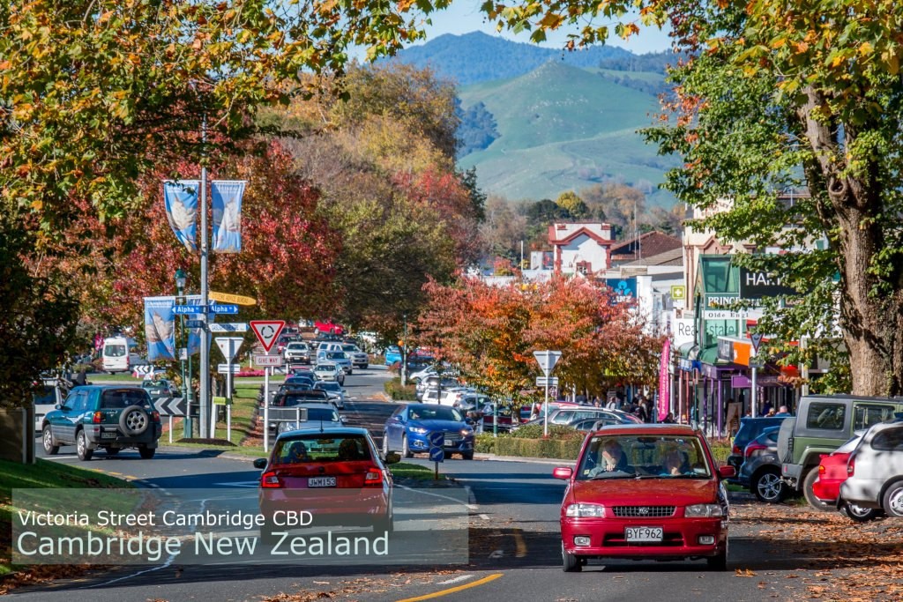
In all, 45 local areas (including smaller cities) benefited from a net gain from internal migration. Reasons include: -
- Remote working enabled by Ultra-Fast Broadband and accelerated by Covid
- Living affordability, especially housing
- Physical attendances at employer less required, and manageable from extended distance
- More balanced lifestyle
Because these drivers for shifting are logical, the demand is likely to continue.
However, will these towns be economically viable? In its article, Infometrics avoids the “elephant in the room” - the inadequacy of the rating base and the desperation of councils to fund the tsunami of infrastructure spend and voter demands. Three Waters, trophy ports and airports, tourism facilities, conference centres, flood and drought mitigation head LGNZ’s list of challenges. Local body governance is under real pressure, as exhibited by increased back-biting.
If a new funding model for local government is introduced alongside population growth, perhaps the prediction of “zombie towns” is no longer tenable. With a vibrant and welcoming community, energetic newcomers keen to join and contribute, wise civic leadership and pro-active marketing, the prophesied doom of regional towns should be avoided.
Continuing growth and sustainability of regional towns will be good for the whole country, as it goes some way to redressing the Auckland imbalance whose net international immigration at +36,700 is trending lower but still stressful. By all criteria, reweighting our demographic geography is a win-win.

